Vaults with ORM Stack

Contents

1. Introduction 1
2. Workflow diagram to deploy the stack 3
3. Create Stack 4
4. Upload the Artifacts 4
5. Create Vault Key Management System 5
6. Plan the Job 6
7. Apply the Job 7
8. Note down the “Management Endpoint URL” from the “output.tf” 8
9. Verify in the Console 9
10. Destroy the stack 10

Introduction

This is KMS Vault Key Management System. It stores and manages master encryption keys and secrets for secure access to resources. It securely store master encryption keys and secrets that you might otherwise store in configuration files or in code.

The key encryption algorithms that the Vault service supports includes the Advanced Encryption Standard (AES), the Rivest-Shamir-Adleman (RSA) algorithm, and the elliptic curve digital signature algorithm (ECDSA).

You can create and use AES symmetric keys and RSA asymmetric keys for encryption and decryption. You can also use RSA or ECDSA asymmetric keys for signing digital messages.

You can use the Vault service to create and manage the following resources:

- Vaults
- Keys
- Secrets

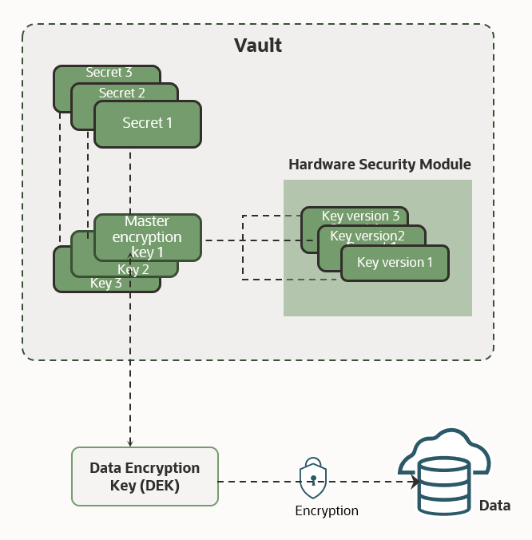

Vaults are logical entities where the Vault service creates and durably stores vault keys and secrets. The type of vault you have determines features and functionality such as degrees of storage isolation, access to management and encryption, scalability, and the ability to back up.

The type of vault you have also affects pricing. You cannot change a vault's type after you create the vault. The Vault service offers different vault types to accommodate your organization's needs and budget. All vault types ensure the security and integrity of the encryption keys and secrets that vaults store.

Workflow diagram to deploy the stack
Below diagram shows how the Terraform Artifact are applied in the OCI. While creating a ORM stack, using terraform deliverables Init, Plan and Apply is the flow to provision the resource in the OCI. We can have the deliverables in any of below.
GitLab/GitHub Repo
Bitbucket
- Can be in folder/.zip in the local disk
- Object Storage Bucket
- Can be in compartment
- Oracle provided Template


Pre-request: Verify the below files present.
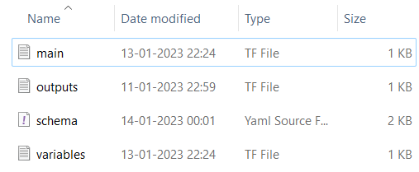

Create Stack

Go to OCI Console Developer Services Resource Manager Stacks select the compartment Create Stack
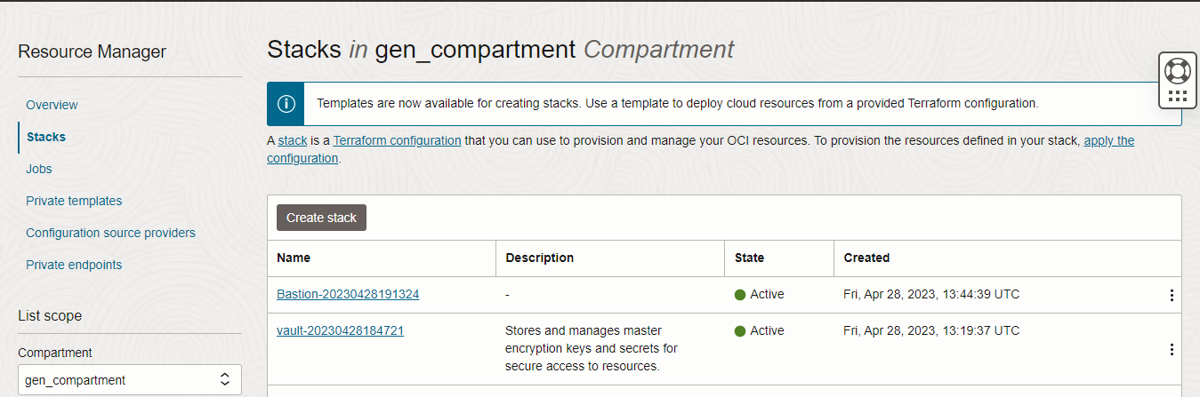

Upload the Artifacts

My Configuration Folder Browse

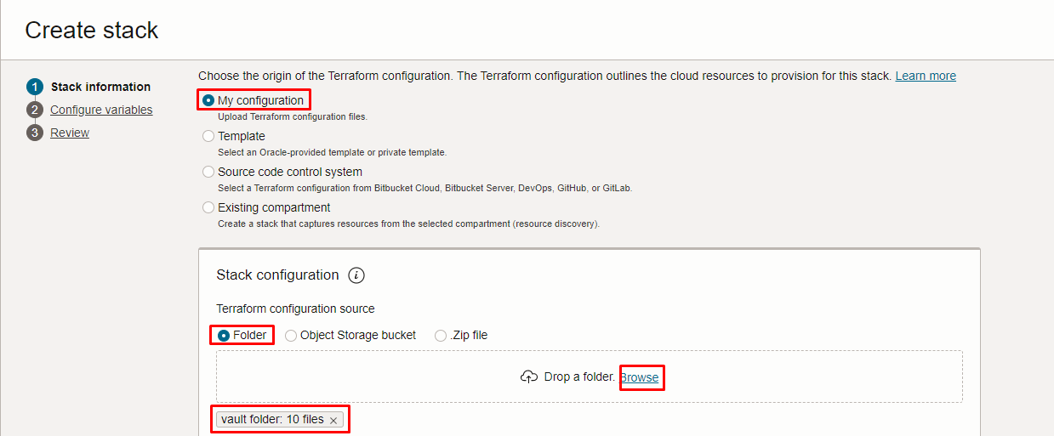

Select the vault folder that contains the terraform and yaml Upload
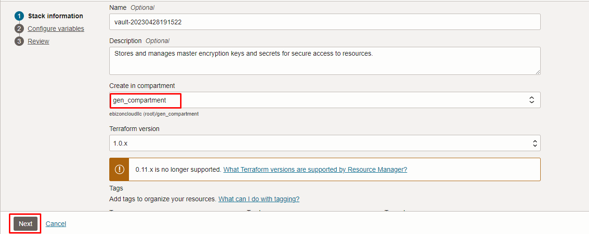

Click “NEXT”

Create Vault Key Management System

Select the compartment, to create the Vault key
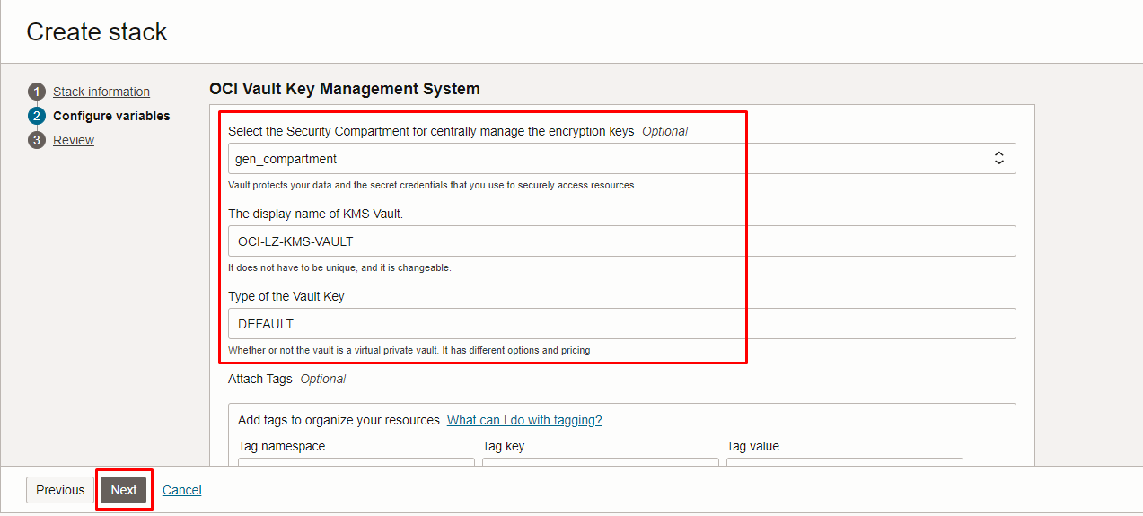

Click “NEXT”

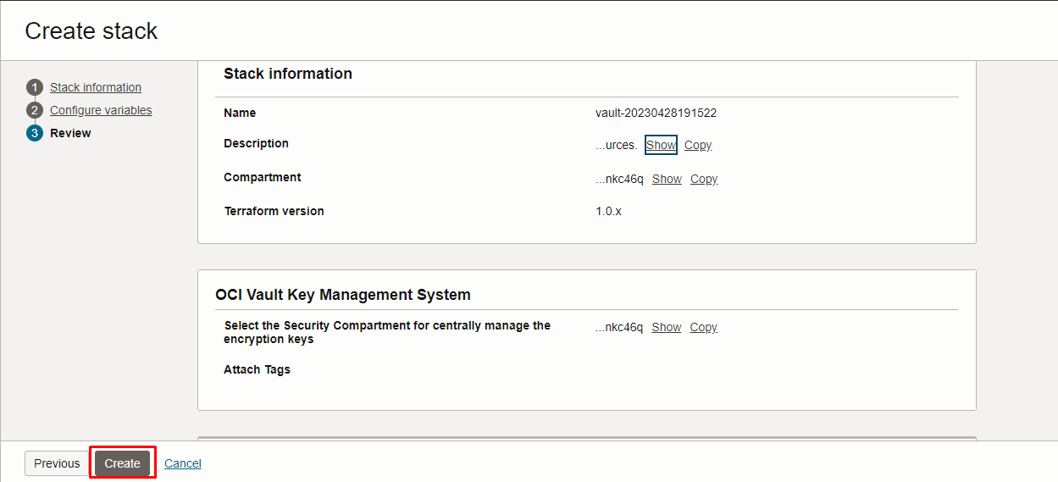

Click “CREATE”

Plan the Job

Click the “Plan”

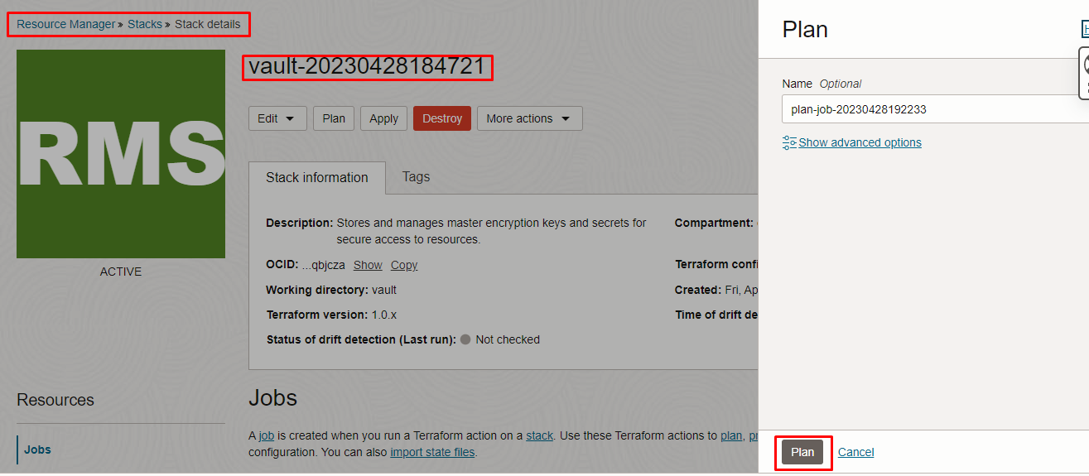

Verify the Plan is successful.
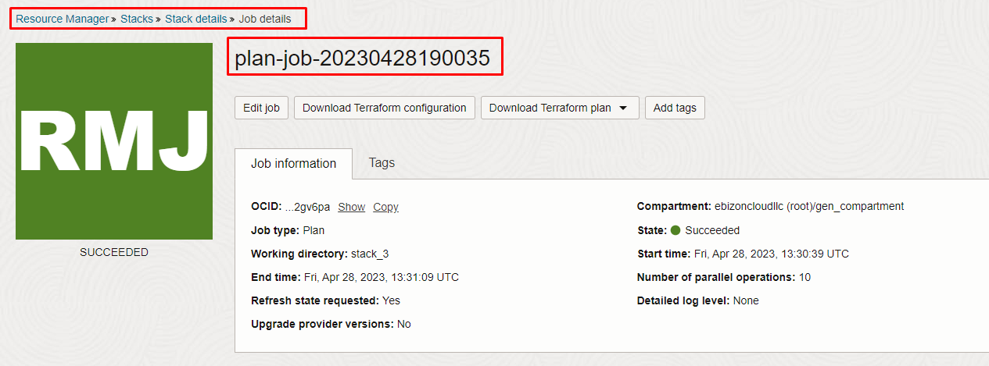

Apply the Job

Once the “plan” is success, now click “Apply”
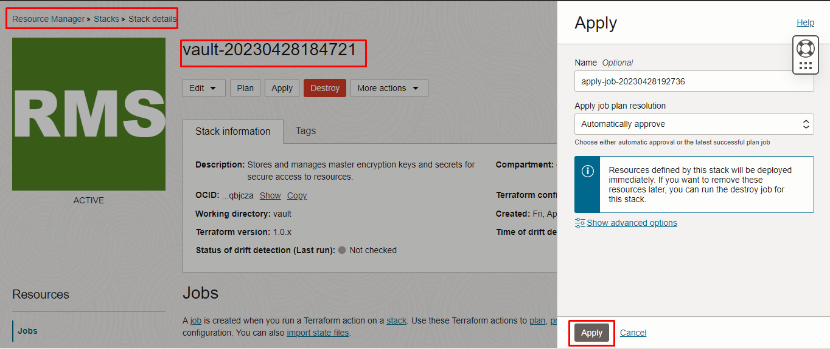

Verify the Apply is successful.
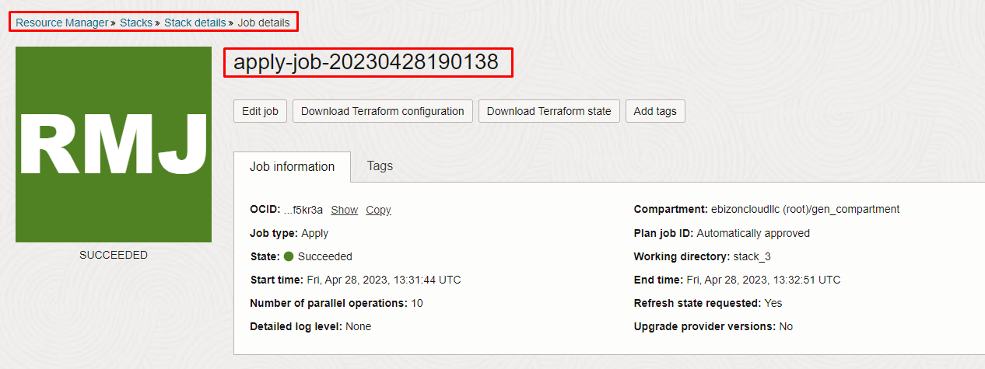
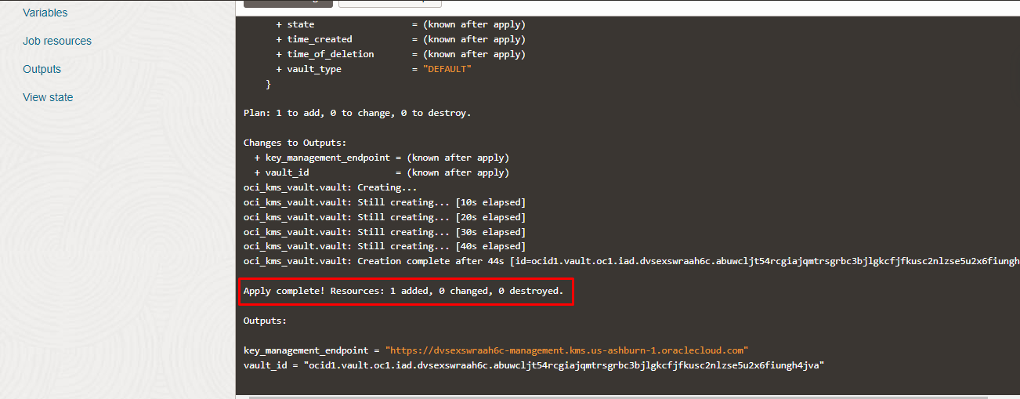

Note down the “Management Endpoint URL” from the “output.tf”

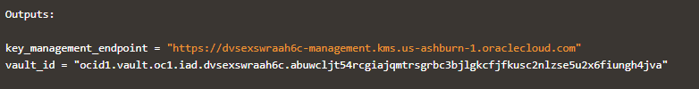

Verify in the Console

Go to OCI Console Identity and Security Vault

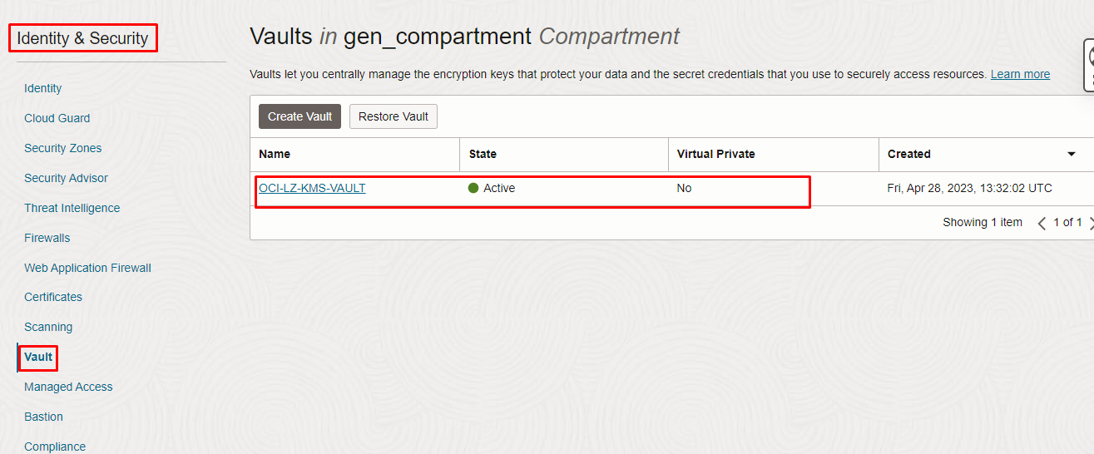

Once the “Key” stack applied the “master encryption keys” will be created. Now it is “no items found”

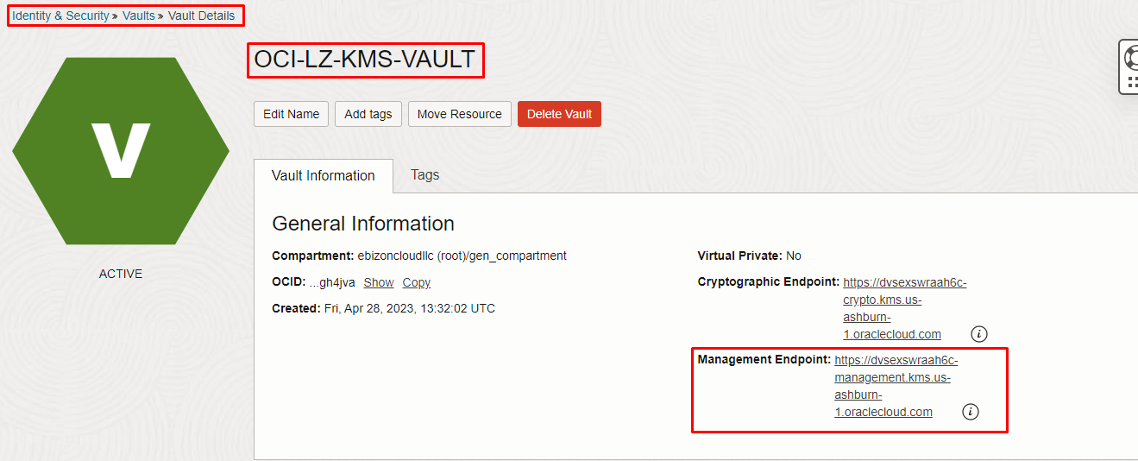
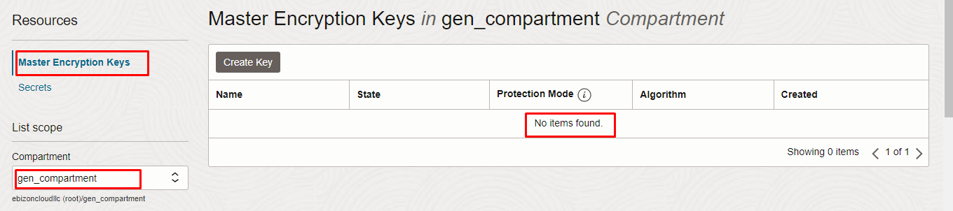

Destroy the stack
Create a destroy job in Resource Manager to release resources associated with a stack and clean up the tenancy. Once destroyed data cannot be recovered from resources.

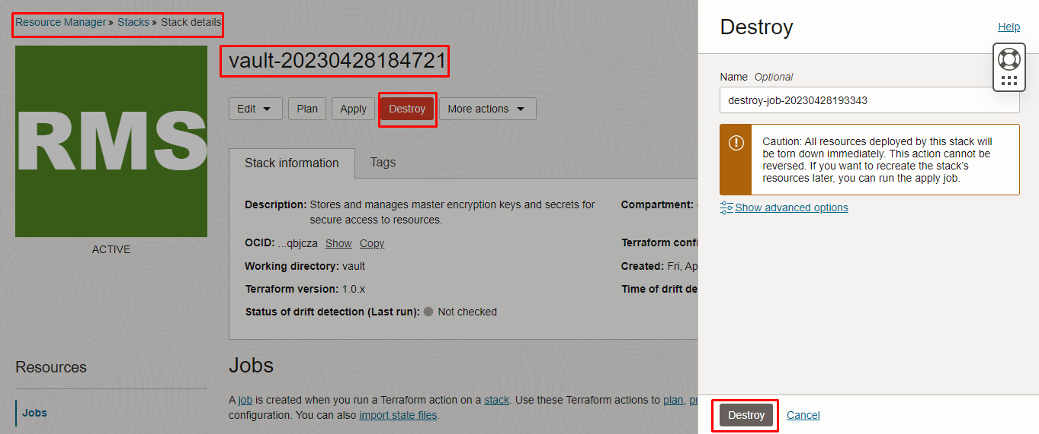
# END #

